# EcoPRT Vehicle Network Solution User Guide

### Overview

This guide is to help those who are new to the application. It should clear up any confusion on how to get to the different pages and what you can do at each one. Before continuing in this guide, make sure you have followed the Installation Guide to get the application up and running. Also look at our Glossary (Table 1) to learn about different terms used throughout the guide.

### Installation Guide

To install our application please follow the installation guide provided.

### Glossary

|  |  |
| --- | --- |
| **Term** | **Description** |
| Vehicles | The autonomous vehicles that someone can ride |
| Telemetry | Information about the vehicles   * Includes: battery life, coordinates, steering angle, heading angle, current task   + Heading Angle: The angle the front of vehicle is facing   + Steering Angle: The angle the front wheels are facing   + Coordinates: Latitude and Longitude of the vehicle |
| Vehicle History | This is a collection that holds all the telemetry for all the vehicles in the system |
| Nodes | Points on the map that the vehicle can drive to   * Can be of four types: pickup station, charging station, docking station or just a normal point on the path |
| Edges | Path between two nodes |
| Rides | Information about all rides that have taken place or are in progress   * Includes: vehicle used, user who requested vehicle, stations chosen, time of pickup and dropoff, and whether the ride was completed. |
| Admin User | Users in the system that can view all aspects of the system like vehicles, nodes, edges, and rides. They can also issue commands to vehicles and tell them what stations to go to. |

Table 1

#### 

### Home Page (Figure 1)

What is Shown

* This is the page you start out on when using the application
* There is a navigation bar on top of this page and throughout the application
* The navigation bar contains links to the home page, login page, and sign up page along with a menu with links that go to the different sections on the homepage that you can read.
* The home page has 3 different sections for you to read
  + Overview
    - Contains information about what the EcoPRT project is
  + About the Developers
    - Contains information about the developers who created the application
  + Contact Us
    - Contains information on how to contact the developers or people in charge of the EcoPRT project

How to use

* Get to Home Page
  + Click “Home” on navigation bar
* Going to Different Web Pages
  + You need to click on the links in the navigation bar at the top to get to the respective web page.
* Going to Different Sections of Home Page
  + Click the Menu link at the top right and a menu appears
  + Click on a certain section and the home page will move to that section for you to read

#### 

Figure 1 - Home Page

### Signup (Figure 2)

What is Shown

* The login page has the same navigation bar as the home page including the menu with links to sections on the homepage. This page also includes several fields for user input.
* The field labeled Username is where you enter the username you want for your account.
* The field labeled First Name is where you enter your first name.
* The field labeled Last Name is where you enter your last name.
* The field labeled Birthday is where you enter your date of birth
* The field labeled Email Address is where you enter your email address
* The field labeled Password is where you enter the password you want to use
* The field labeled Confirm Password is where you re-enter the password you want to use
* There are two buttons at the bottom of the page
  + Red “Back To Homepage” button that goes to the homepage and a
  + Blue “Sign Up” button that will verify that the input in the fields listed above are valid and submit the information.
  + The “Sign Up” button will redirect you to the Login Page if the input fields above all have valid input.
  + If the fields do not contain valid data, the button will try to submit the data and give an error message that tells you what data is incorrect.

How to Use

* Get to Sign In Page
  + Click “Sign In” on navigation page
* Going to Different Web Pages
  + You need to click on the links in the navigation bar at the top to get to the respective web page.
* Going to Home Page
  + You can click the Home link in the navigation bar to get to the home page
  + You can also click the red “Back to HomePage” button to go to the home page
* Signing Up to Application
  + Fill in all the fields on the web page
  + Click the blue “Sign Up” button

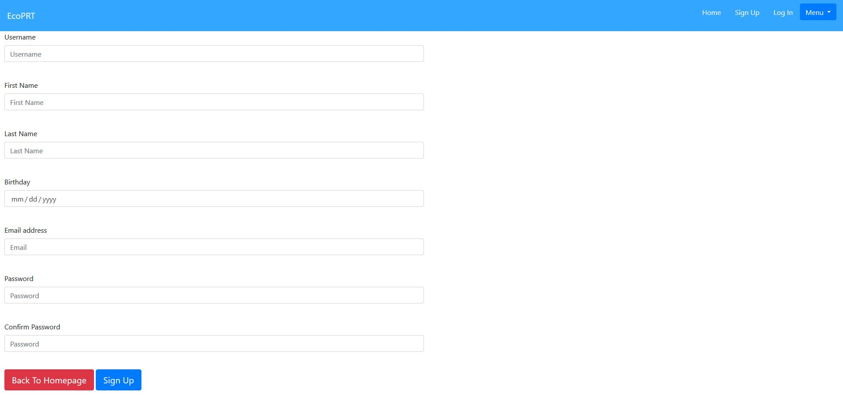

Figure 2 - Log In Page

### Login (Figure 3)

What is Shown

* The login page has the same navigation bar as the home page including the menu with links to sections on the homepage. This page also includes two fields for user input.
* The first field labeled Email Address is the field to enter the email address that is associated with your account.
* The second field is the password field where the password to your account should be entered.
* There are two buttons at the bottom of the page
  + Red “Back To Homepage” button takes the user back to the homepage and the
  + Blue “Sign in” button will allow you to sign into the account associated with the credentials entered into the Email Address and Password fields mentioned above
  + If the credentials entered are associated to an administrator account, the user will be brought to the Admin page

How to Use

* Get to Login Page
  + Click “Log In” on navigation bar
* Different Web Pages
  + You just need to click on the link in the navigation bar at the top to get to the respective web page.
* Going to Home Page
  + Click the Home link in the navigation bar to go to home page
  + Click the red “Back To Homepage” button to go to home page
* Log In to Application
  + Fill in the all the fields on the web page
  + Click the blue “Sign In” button to login in to the application

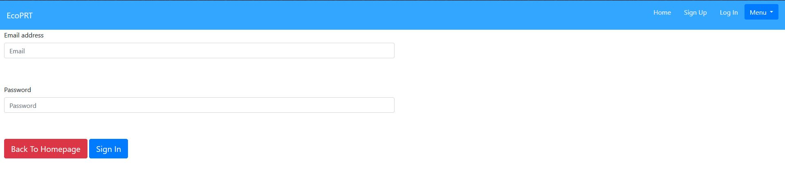

Figure 3 - Sign Up Page

#### 

### Admin Page

What is Shown

* The Admin page contains a navigation bar with a sign out link in the top right
* There is a Google map on this page that displays all nodes, edges and vehicles that are currently in a ride. This is shown below in Figure 4.
  + Nodes are the blue dots
  + Edges are red lines between nodes
  + Vehicles are the black car icons
    - The icon is rotated based on the heading angle with an arrow pointing in the right direction

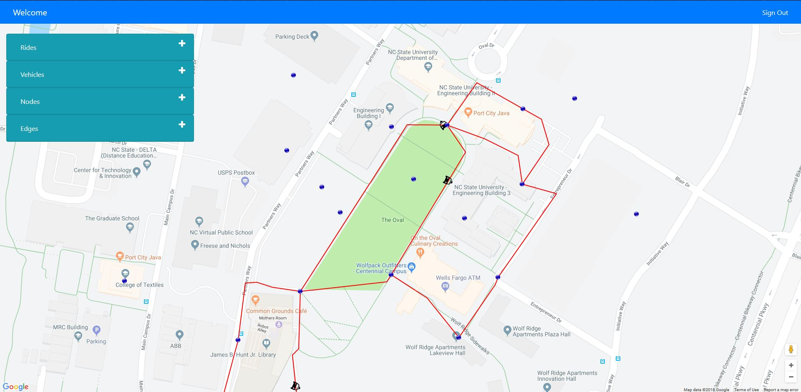

Figure 4 - Starting Page for Admin

* There are dropdowns on the left that you can click to see more information about vehicles, nodes, edges and rides
* As an admin you will have the ability to add nodes, vehicles, edges and rides using the plus button in the dropdown

How to Use

* Login as admin
  + Go to Login page (Look at Login Page section)
  + Fill in email with [admin@example.com](mailto:admin@example.com)
  + Fill in password with admin
  + Click blue “Sign In” button
  + You will be sent to Admin page
* Signing Out of Admin Page
  + Click the Sign Out link in the navigation bar at the top right
* Adding Edge, Vehicle, Ride (Figure 5 & 6)
  + Click the plus button for the respective dropdown on the right hand side of the menu
  + A form for that respective item will appear
  + Fill in all the fields
    - For Edges:
      * When selecting a start and end node, you can click the mouse pointer icon to select a node on the map instead of using the dropdown provided
      * You also need to submit a waypoint file
    - For Rides:
      * When selecting a vehicle you have two options
        + You can choose from a dropdown of all vehicles in the database
        + You can have a vehicle picked for you by an algorithm to choose the most available vehicle by clicking the checkbox named “Don’t Require Vehicle Selected”
  + Click the red “Add” button
  + The item will appear on the map with its corresponding icon and in the table in the dropdown for that item

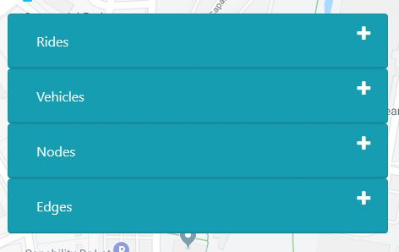

Figure 5 - Dropdowns for Adding Rides, Vehicles, Nodes, and Edges

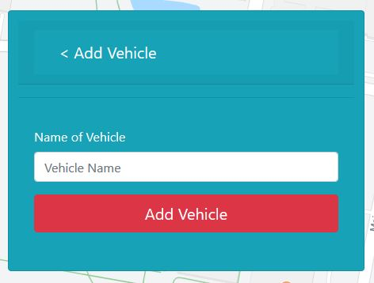

Figure 6 - Add Vehicle Form

* Adding a Node
  + Option 1
    - Click the plus button for the node dropdown on the right hand side of the menu
    - A form for adding nodes will appear
    - Fill in all the fields
      * To fill in coordinates you can:
        + Manually enter Latitude and Longitude
        + Click the white place icon on the top right

When clicked you can click anywhere on the map and the coordinates fields will auto fill

* + - Click the red “Add” button
    - The node will appear on the map with its corresponding icon and in the table in the dropdown
  + Option 2 (Figure 7 & 8)
    - You can do Shift-Click anywhere on the map
    - A menu with “Create New Node Here” will appear
    - When that is clicked, the add Node form will appear
    - The coordinates will be auto filled
    - Fill in the rest of the fields
    - Click the red “Add” button
    - The node will appear on the map with its corresponding icon and in the table in the dropdown

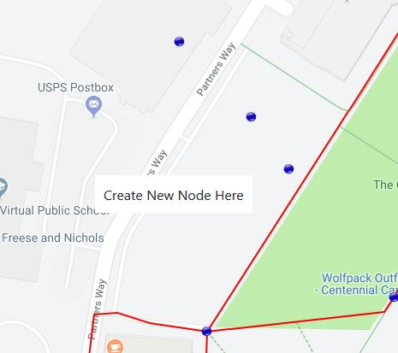

Figure 7 - Create New Node Here menu

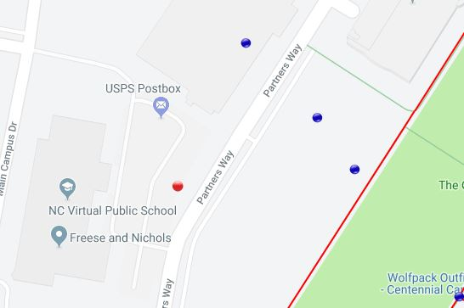

Figure 8 - New Node (red circle) is Created at Selected Location

* Viewing a Node, Edge, Vehicle, Ride
  + The respective items will show on the map on the Admin page to see
    - Nodes are the blue dots
    - Edges are the red lines
    - Vehicles are the black cars
    - Rides are when the vehicles are moving along edges on the map
  + You can view information about the different items by clicking on their icons on the map (Figure 9)
    - An info bar will appear at the bottom of the screen with more information about that item
    - The selected icon will change color to visualize that it is selected
      * Nodes will turn red
      * Edges will turn green
      * Vehicles will turn blue
  + You can also click on the dropdowns to view all entries of a specific item in the database with more information (Figure 10)
    - The information is in a table format with a scroll bar

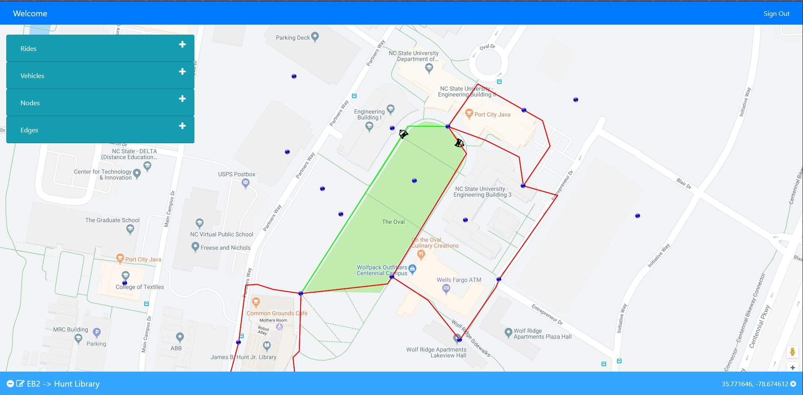

Figure 9 - Clicked Edge with Info Bar

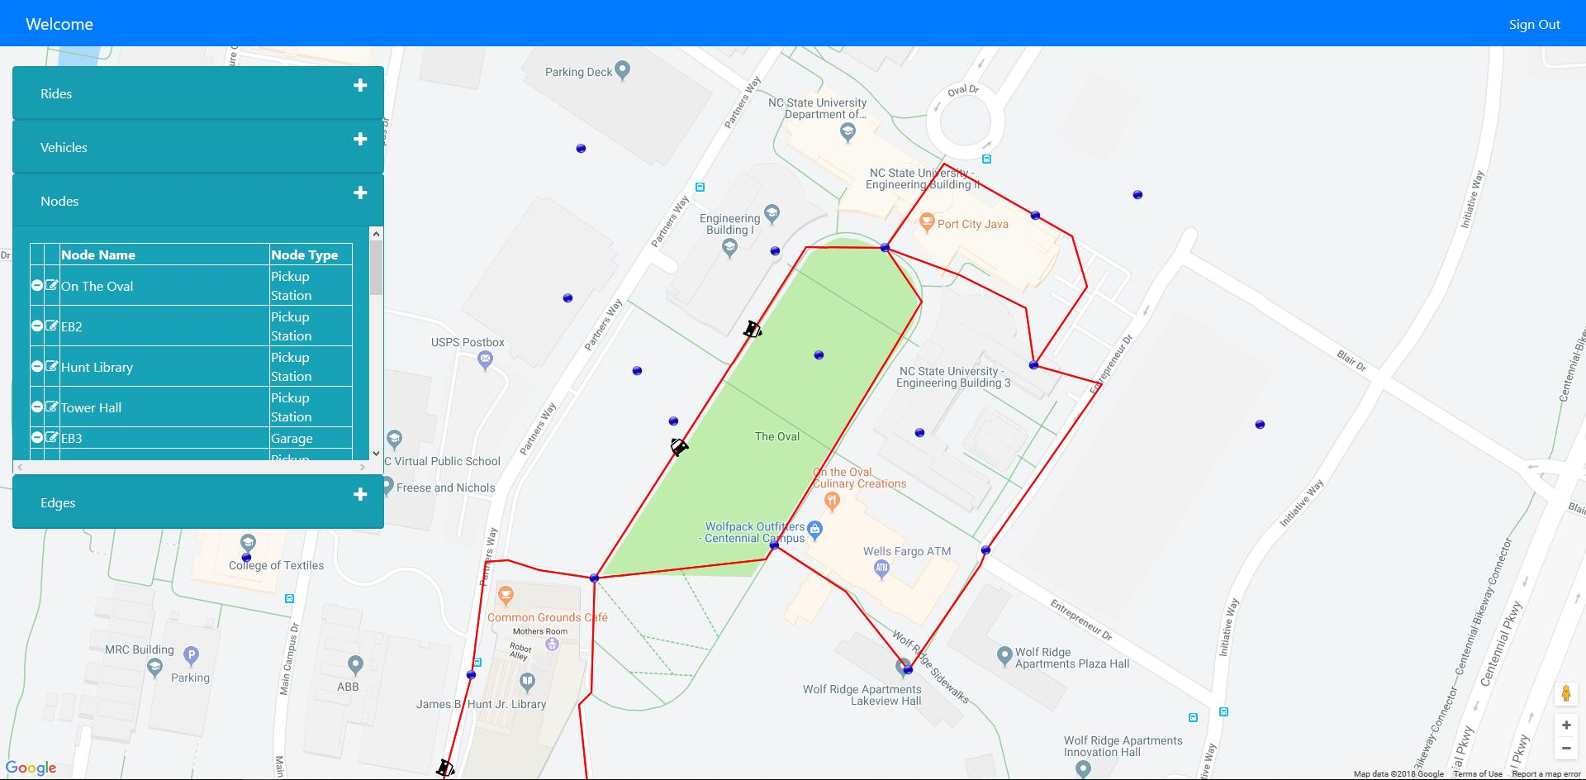

Figure 10 - Node Dropdown Expanded

* Editing a Node, Edge, Vehicle, Ride
  + Click on an icon for a specific item to bring up the info bar (Figure 11)
    - The left hand side of the info bar will have an edit icon (pencil icon)
      * When clicked it will bring up an edit form on the item’s respective dropdown (Figure 13)
      * Fill in all the fields
      * Click the red “Edit” button
  + You can also edit an item by clicking the respective dropdown and clicking the edit icon (pencil icon) on the table for a specific entry (Figure 12)
    - It will bring up the edit form for you to use
    - Fill in all the fields
    - Click the red “Edit” button

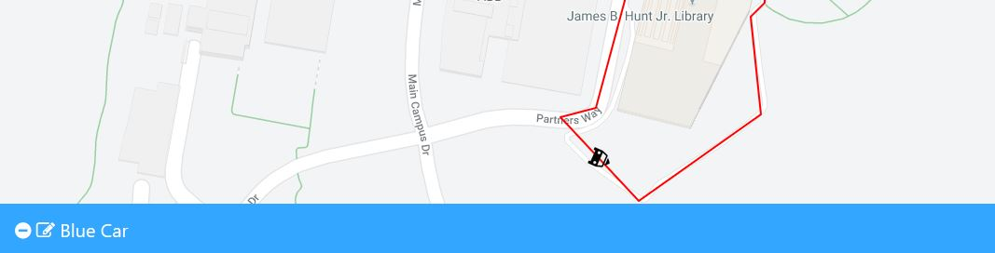

Figure 11 - Info Bar for Blue Vehicle

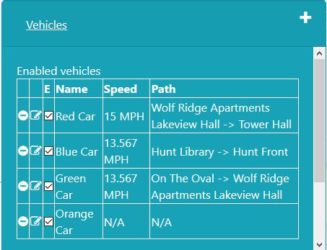

Figure 12 - Vehicle Table

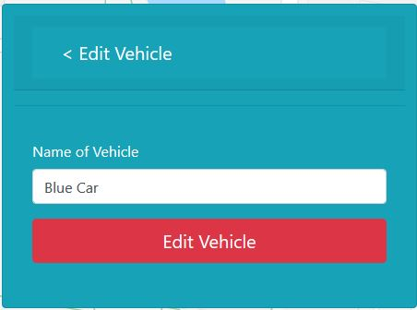

Figure 13 - Edit Vehicle Form

* Deleting a Node, Edge, Vehicle
  + Click on an icon for a specific item to bring up the info bar
    - The left hand side of the info bar will have a delete icon (minus sign icon) (Figure 14)
      * When clicked it will bring up a pop up alert to confirm your deletion (Figure 16)
      * When you confirm the deletion, you will get another message that says the node was deleted
      * It will delete the icon from the map and table in the dropdown
  + You can also delete an item by clicking the respective dropdown and clicking the delete icon on the table for a specific entry (Figure 15)
    - It will bring up a pop alert for you to confirm your deletion
    - When you confirm the deletion, you will get another message that says the node was deleted
    - It will delete the icon from the map and table in the dropdown

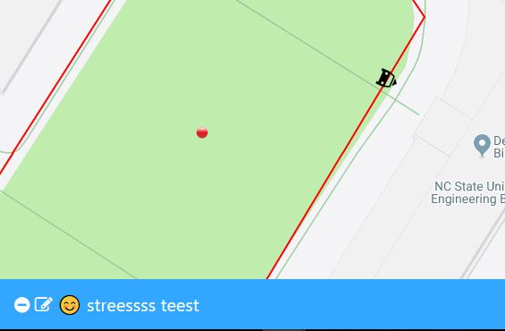

Figure 14 - Info Bar for a Node

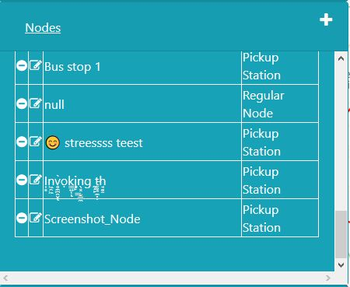

Figure 15 - Node Table

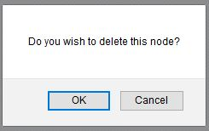

Figure 16 - Deletion Confirmation Alert

* Disable/Enable Vehicle
  + Click the Vehicle dropdown
  + You will see two tables: Enabled and Disabled vehicles
  + Enabled vehicles have a checked checkbox in the E (for Enabled) column
  + To disable a vehicle, you uncheck the checkbox in the Enabled vehicle table to move it to the Disabled vehicle table (Figure 17)
  + To enable a vehicle, you check the checkbox in the Disabled vehicle table to move it to the Enabled vehicle table
  + This will change the enabled value in the database for that vehicle

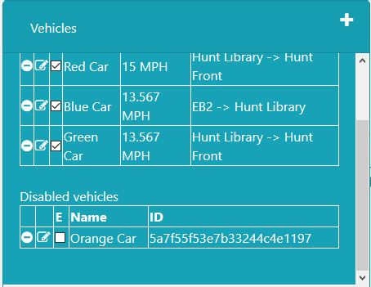

Figure 17 - Disabled Orange Vehicle